

Best Practices

Cloning an Archived Logbook Entry

Cloning an Archived Logbook Entry

To truly make the Archived files more useful we can now clone an archived request.

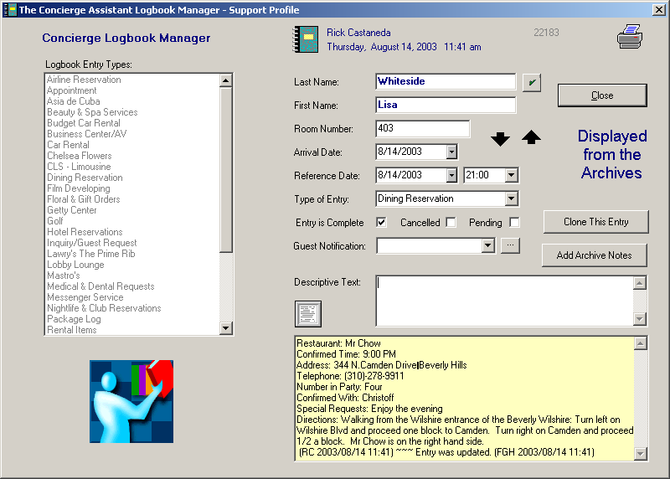

Press this button and you will be presented with the Data Entry Panel for a new Dining Reservation,

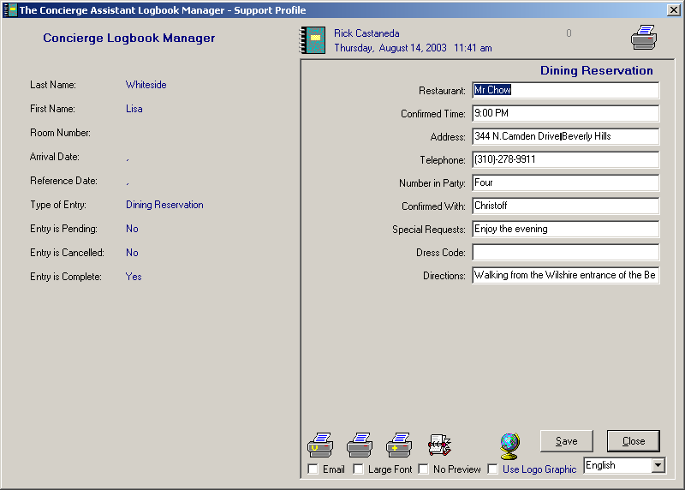

Verify the information, press <Save> and you will see:

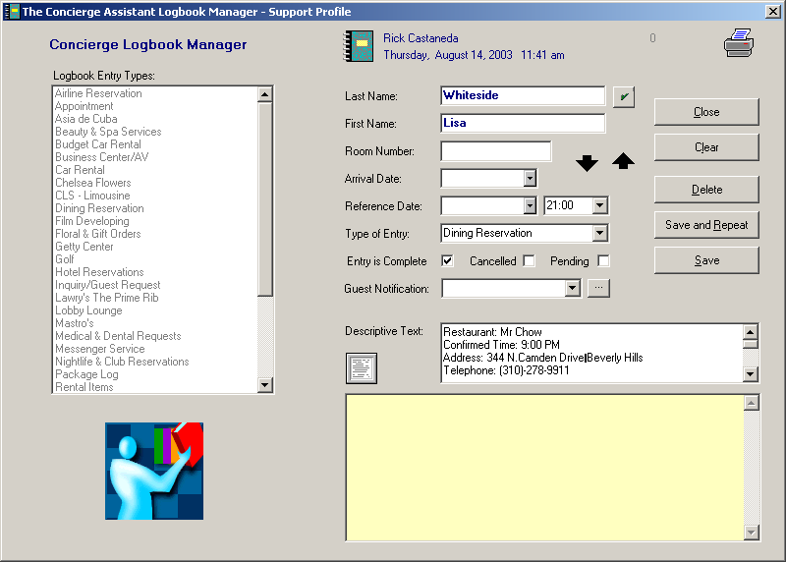

The Room Number, Arrival Date and Reference Date fields have been cleared of the Archive Information. Only the Reference Date is required. Select a Reference Date and press <Save>. You now have a Cloned Logbook Entry from the Archive.

